Arrows vs. lines when making maps
Note-taking
Back to Learning Support
Why does it matter?
Sometimes, we see that lines are used to represent relationships instead of arrows. Arrows require a deeper level of processing to be more explicit about the nature of a relationship, whereas lines can simply indicate the general awareness of a connection that has not been prioritised at higher levels.
This simple decision to use arrows forces us to consider the nature of a relationship more deeply, activating higher-order learning. Consider that an arrow going one way is different to an arrow going another way, which is different to a double-sided arrow, a curly-bracket arrow, or a deliberately non-arrow line.
Take note
The following examples show the same concepts and alternative ways they could be represented. Notice how it appears to be emphasising and representing different types of knowledge, depending on the usage of arrows. Notice also that every arrow combination could be viable based on the lines-only representation. In other words, when only lines are used, the differences that we can see through arrows are completely hidden.
Lines only
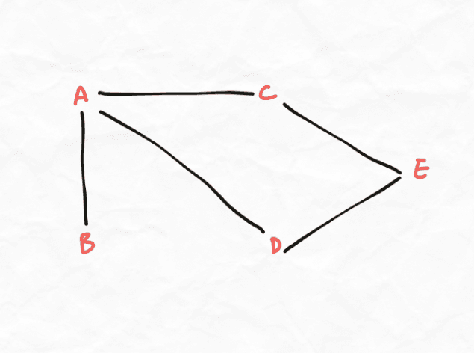
Using arrow combinations
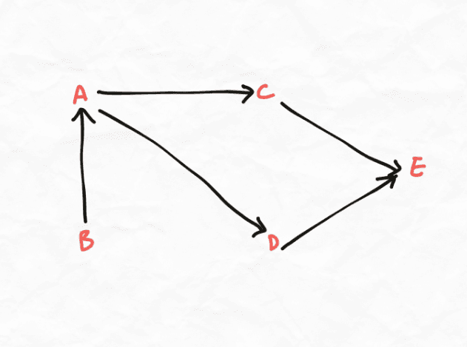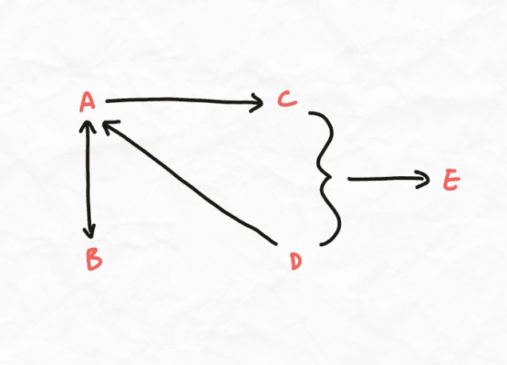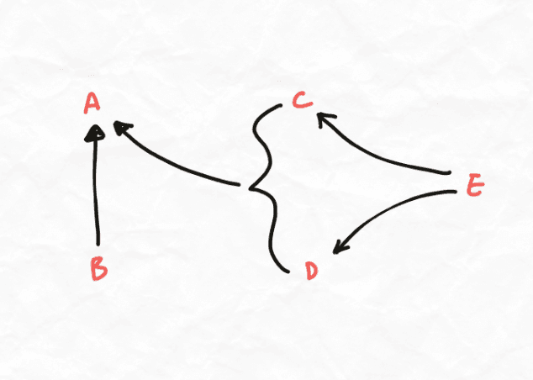
Notice how each combination of arrows indicates a different type of relationship. All of the arrow combinations are variations on the same relationships identified by the lines.
When should I use lines?
Lines are still acceptable to indicate that the information is connected but without any directionality or cause/effect relationship. This is more common in the lower levels of detail, where information in a specific detailed chunk may be split into multiple component facts. The facts may simply exist within this lower-level chunk without having any directionality.

